**Project Explanation:**

**Step1:** While installing the TFS at my environment its throwing the below errors I have installed all the required up to date software’s.

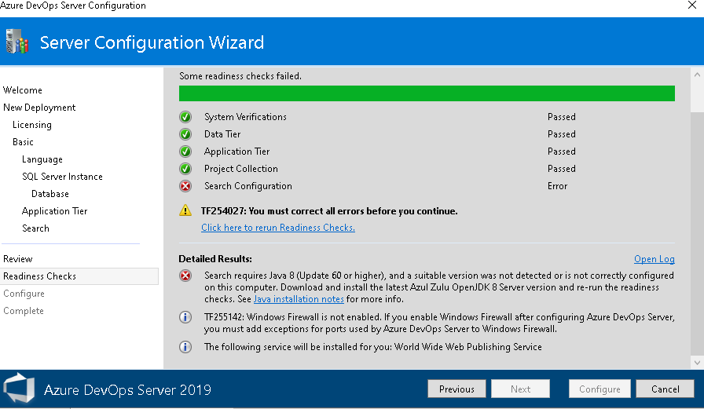

I have tried below scenarios to achieve the requirements.

**Scenario 1:**

I have imported the provided source code as a new project.

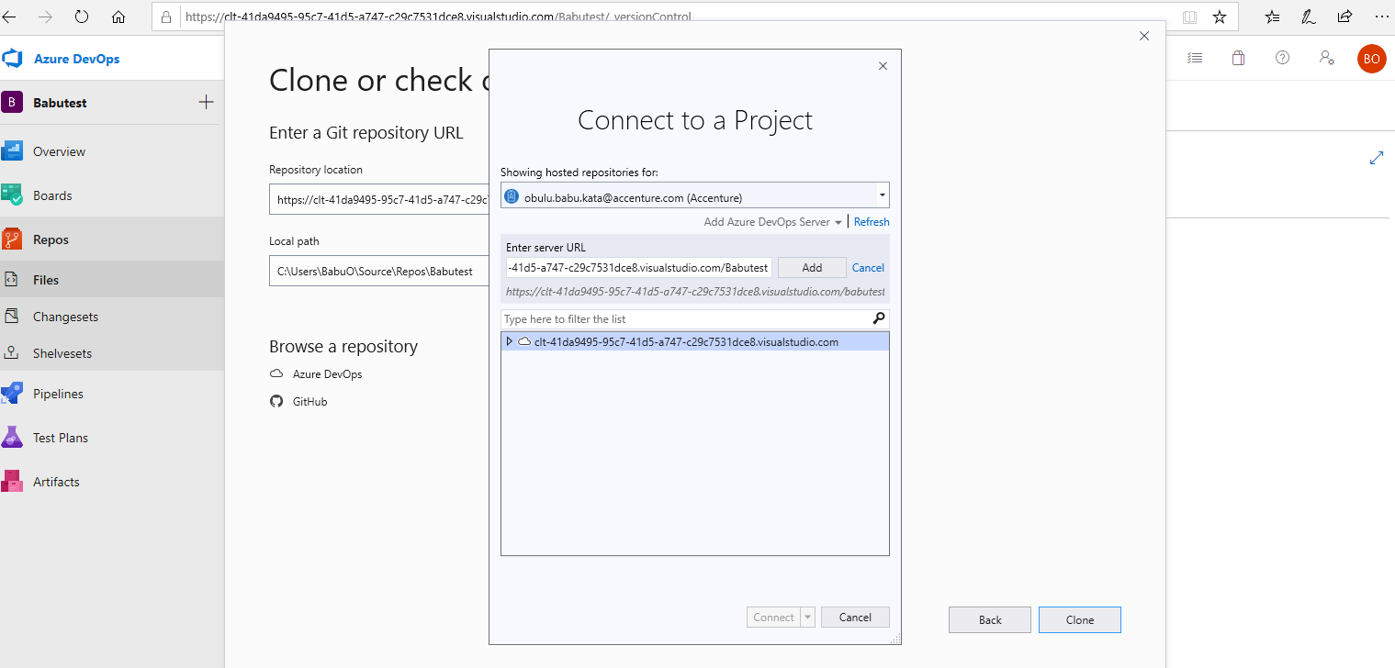

After that I have cloned the repository into locally.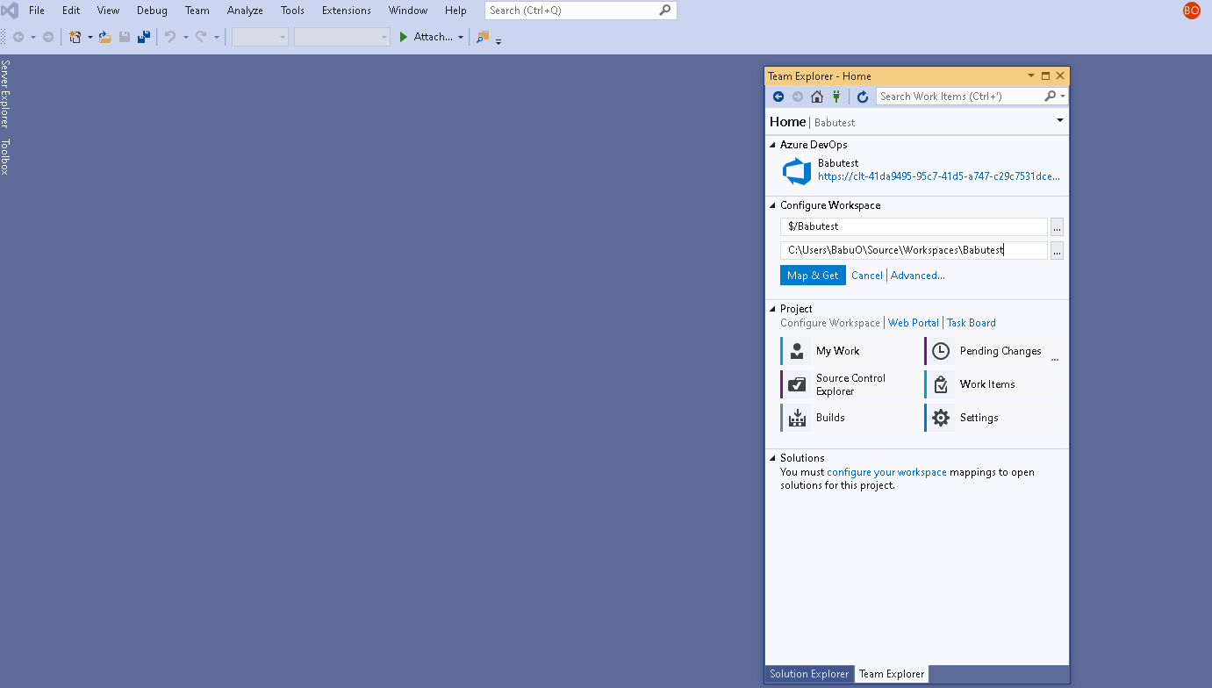

Then I have check in the code local to remote server

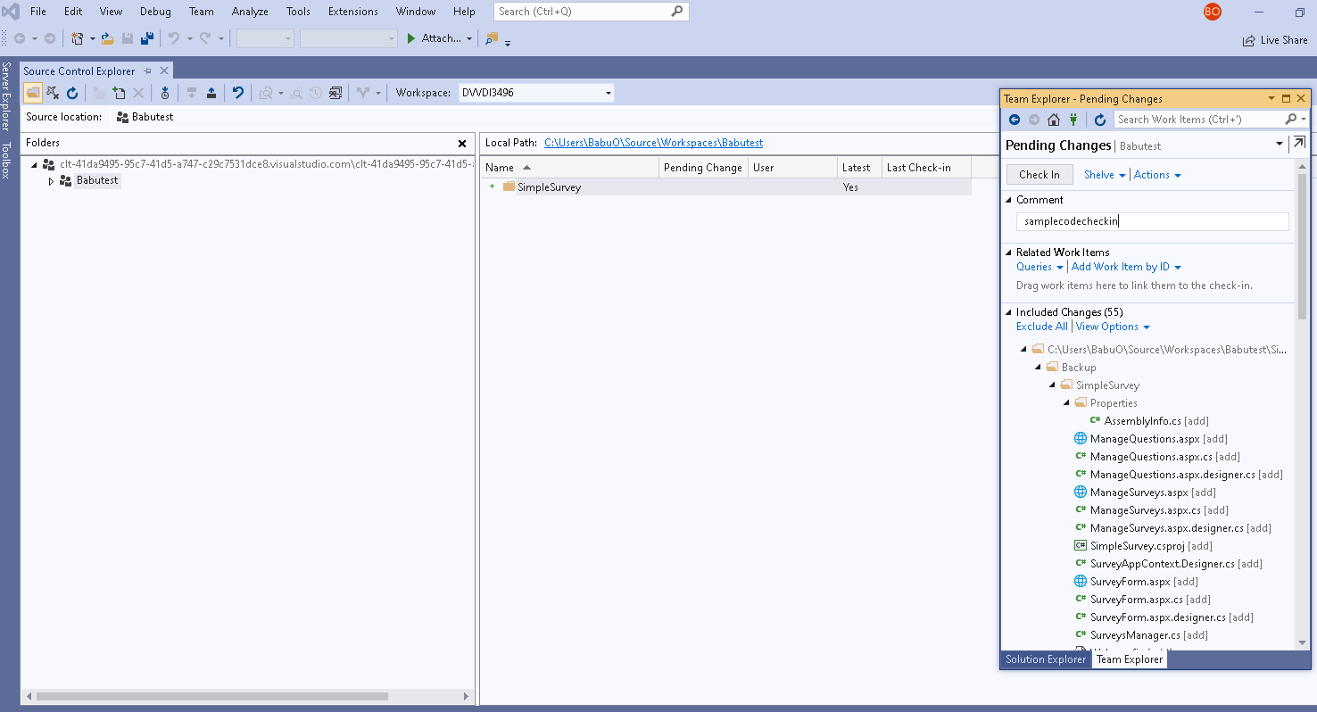

Build the Solution file to get the output:

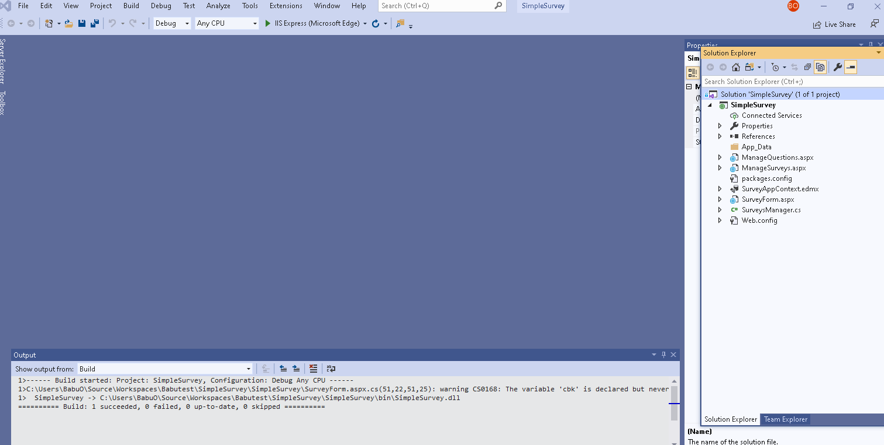

Configured the Continues Integration pipeline to the Project:

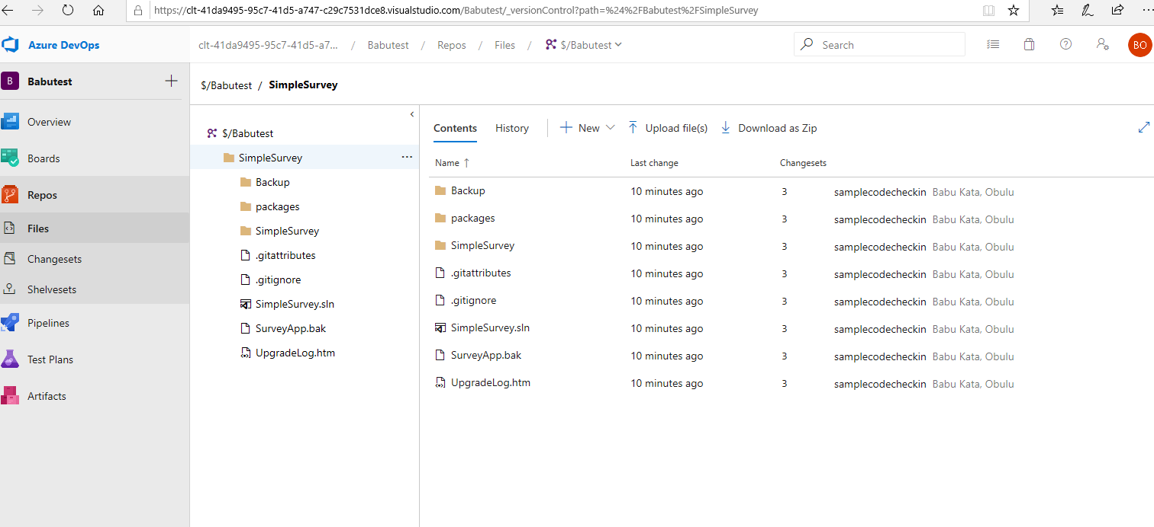

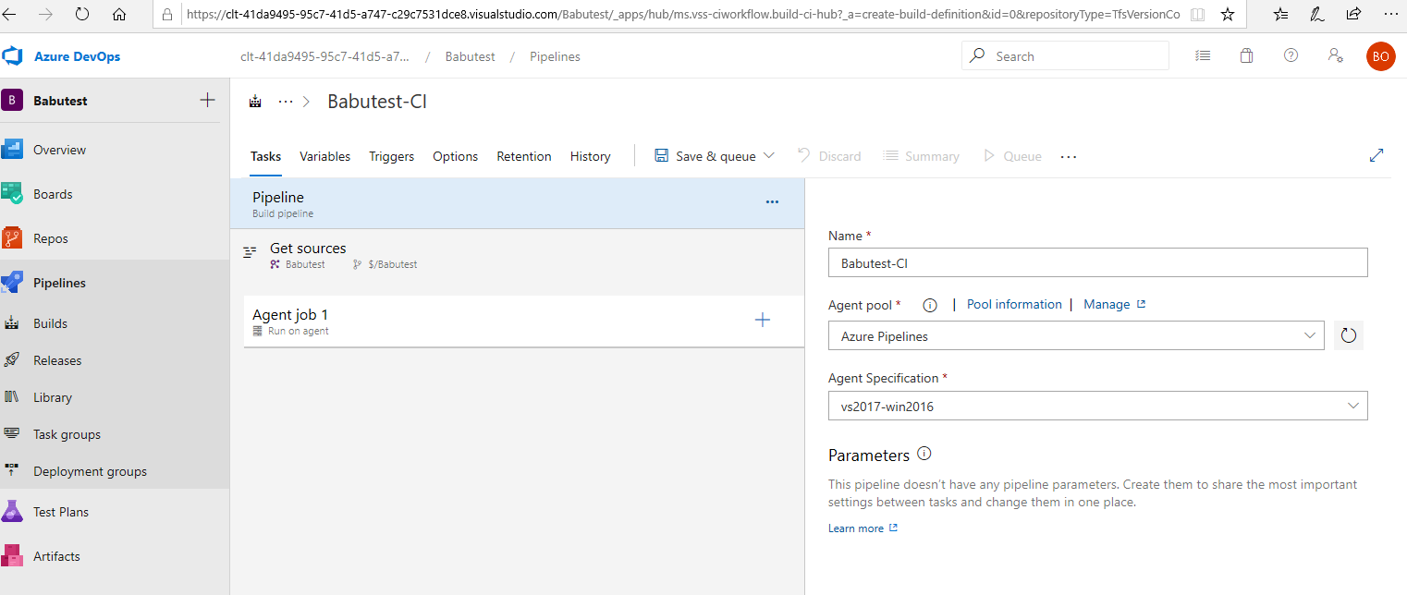

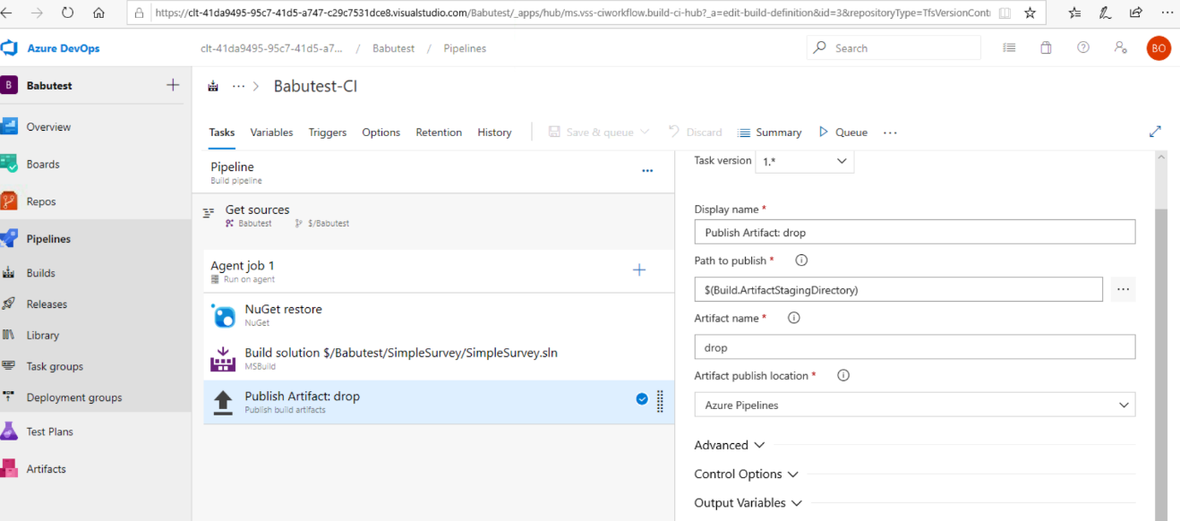run the 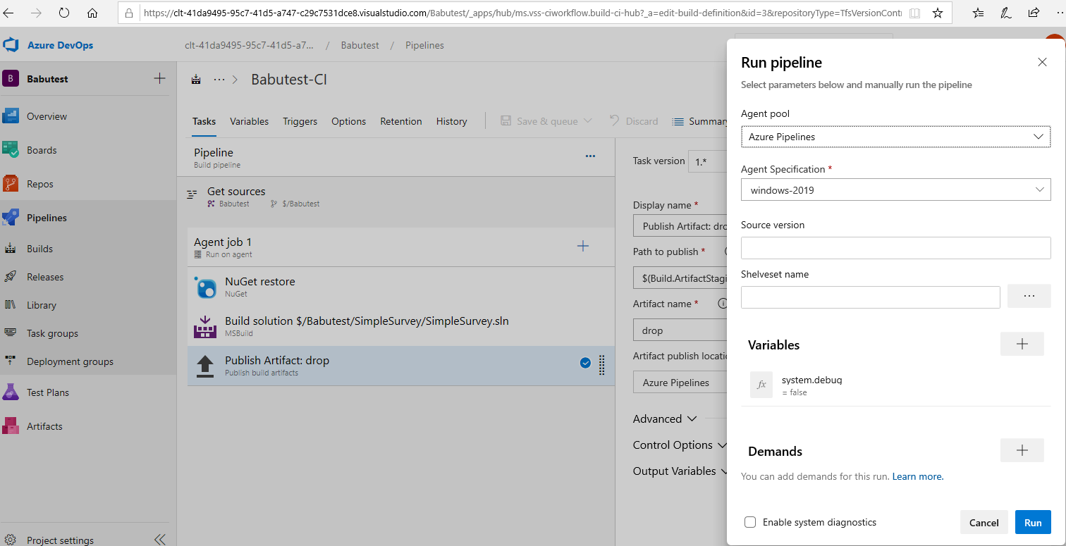

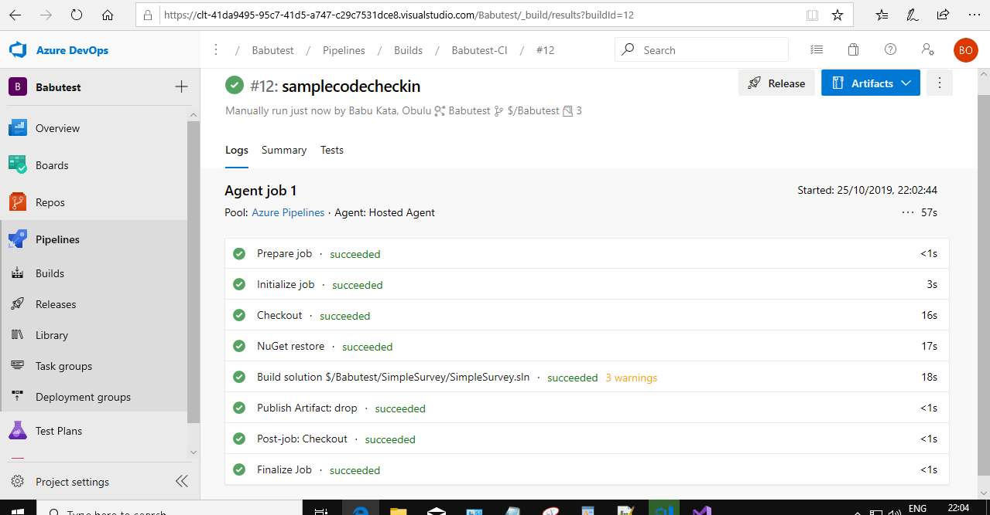

**Output file::**

<https://clt-41da9495-95c7-41d5-a747-c29c7531dce8.visualstudio.com/_apis/resources/Containers/3410570?itemPath=drop%2FSimpleSurvey.zip>

**Successful email::**

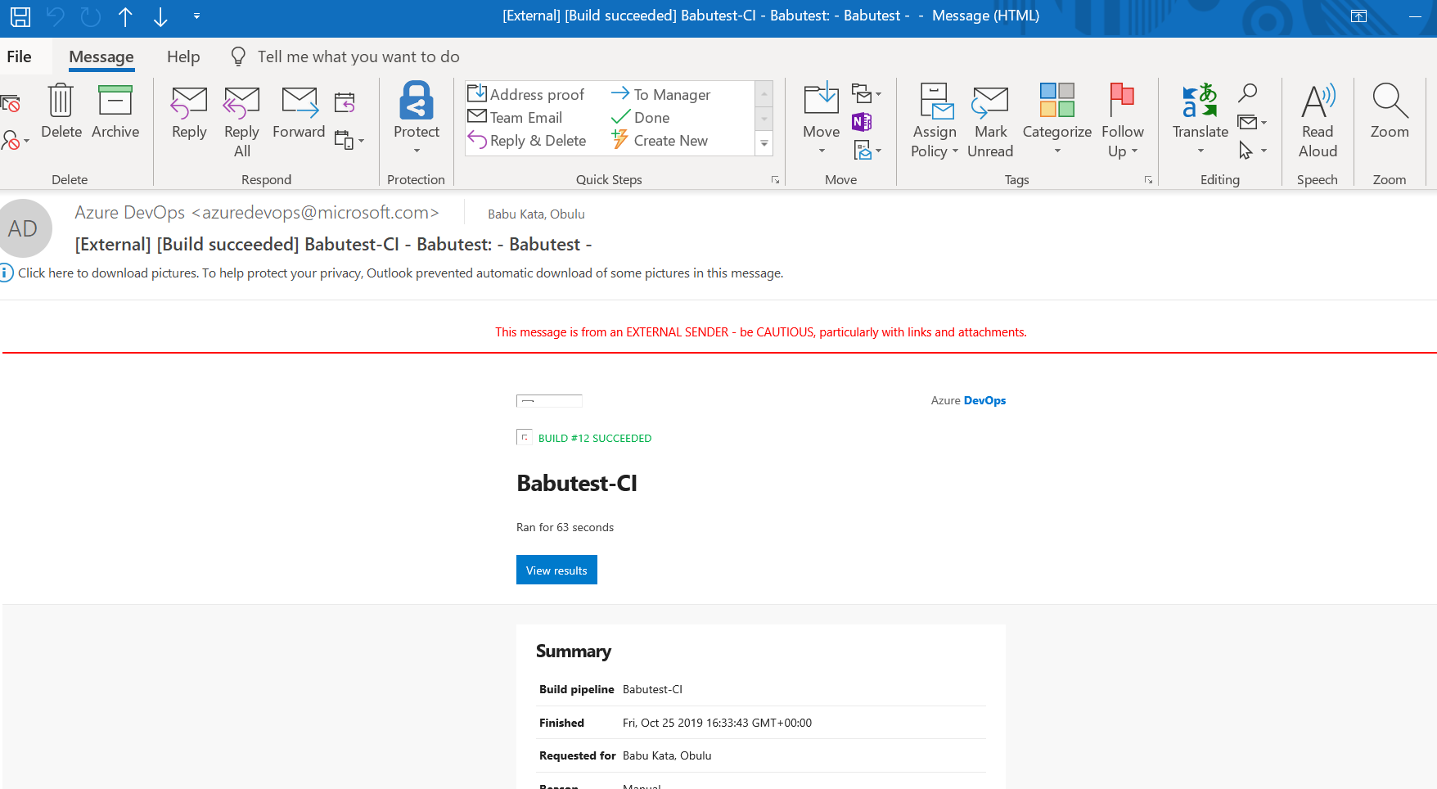

**Scenario 2:**

<https://github.com/obulu/samplebabu.git>

